Student Guide for Respondus LockDown Browser

This guide is to assist you with the process of installing LockDown Browser on your personal computer.
Description provided by Respondus.
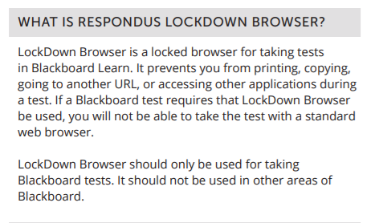

Respondus Link for Parker Students
To use the Respondus LockDown Browser, students will need to install this Browser on their personal computer. This is a one-time installation; you will be able to use this browser for all your tests requiring LockDown Browser in any course at Parker University.
Follow these steps to download the Respondus LockDown Browser:
- Inside of your Blackboard Learn course, you will see a link titled “Student Respondus Link.”
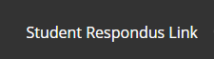
This link is unique for Parker University.
- Click on this link, it will open to the Respondus download page.
  - This product is compatible with both Windows and Mac computers; review system requirements and be sure to select the correct download for your system.
  - A brief introduction video about Respondus is available. Watch the video to become familiar with this product and what you can expect while using this product.
  - Terms and Conditions and the “Install Now” links are located on this page.
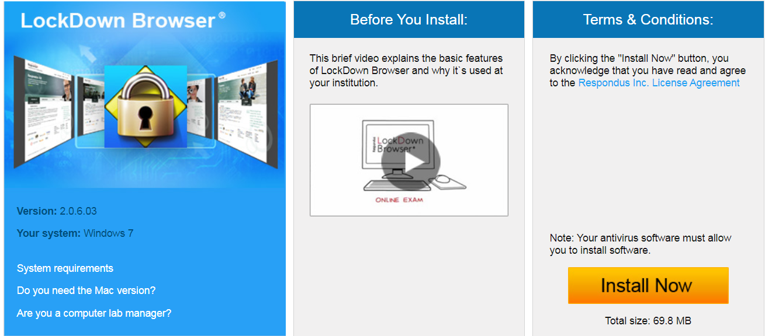

- When you click on the “Install Now” link, it will provide you with a .exe file (Windows version) or a pkg file (Mac). See image below.
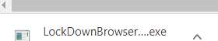
- Click on the run button and follow the prompts to complete your installation of Respondus LockDown browser. The .exe file may be available at the bottom of your screen or in your Downloads folder.
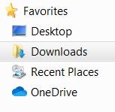
- When the installation is complete, the application will appear in your downloads as seen in the following image.
- Right click on the application and create a shortcut.
Note: You will be required to use this browser for every test requiring Respondus LockDown Browser at Parker University.

- Below is the Respondus LockDown Browser shortcut on the Desktop.
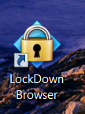
Please note: Respondus will require students to close all other programs currently on their computer prior to opening the test.
In summary, items to do when downloading Respondus LockDown Browser.
- Click on Student Respondus Link.
- Review System Requirements for your specific computer.
- Watch introduction video.
- Click on Install Now button.
- Locate .exe file (Windows) or pkg file (Mac)
- Click on run; follow prompts to complete installation.
- Create Shortcut to Desktop.

For additional student resources for Respondus use the following link. Parker University uses Blackboard Learn and currently we are only using the LockDown Browser from Respondus.
https://web.respondus.com/wp-content/uploads/2019/08/RLDB-Quick-Start-Guide-Bb-Student.pdf

For additional assistance, please contact your designated Technology Representative or AskOnline@parker.edu or Servicedesk@parker.edu.

